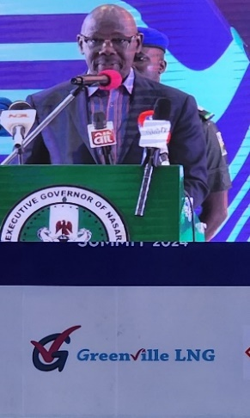

THE EXECUTIVE GOVERNOR OF NASARAWA STATE, HIS EXCELLENCY, ENGR. ABDULLAHI A. SULE SPEAKING AT THE NASARAWA STATE INVESTMENT SUMMIT IN LAFIA, RECENTLY

THE EXECUTIVE GOVERNOR OF NASARAWA STATE, H.E. ENGR. ABDULLAHI SULE (2ND FROM RIGHT), EVP, GAS POWER & NEW ENERGY, NNPCL, MR OLALEKAN OGUNLEYE (FIRST FROM RIGHT) AND GREENVILLE LNG STAFF AT THE GREENVILLE PAVILION DURING THE NASARAWA STATE INVESTMENT SUMMIT IN LAFIA RECENTLY

