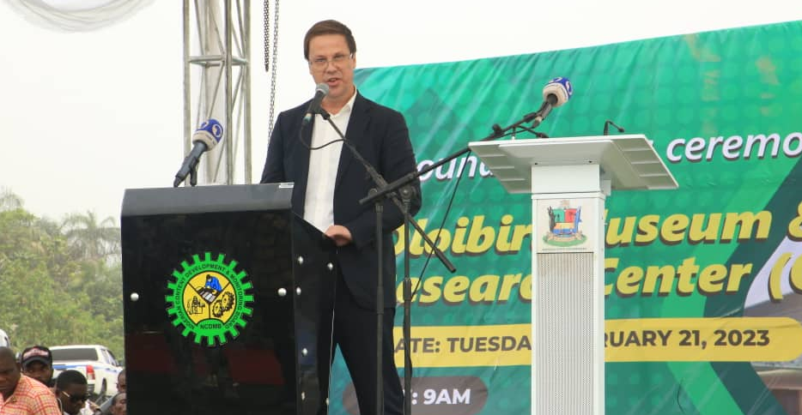
The Managing Director, Julius Berger Nigeria Plc, Engr. Dr. Lars Richter making his
remarks at the Ground-breaking ceremony of the Oloibiri Museum last Tuesday.

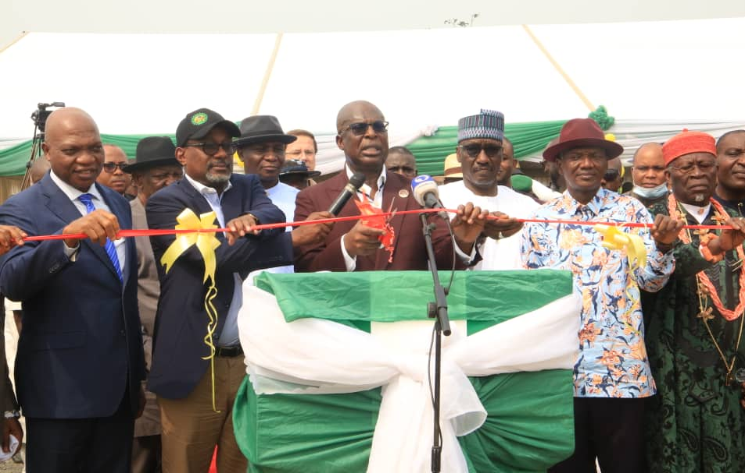
The Hon. Minister of State, Petroleum Resources, His Excellency, Timipre Sylva cutting the ribbon to flag off the works of the Oloibiri Museum at the Ground-breaking ceremony for the Project last Tuesday

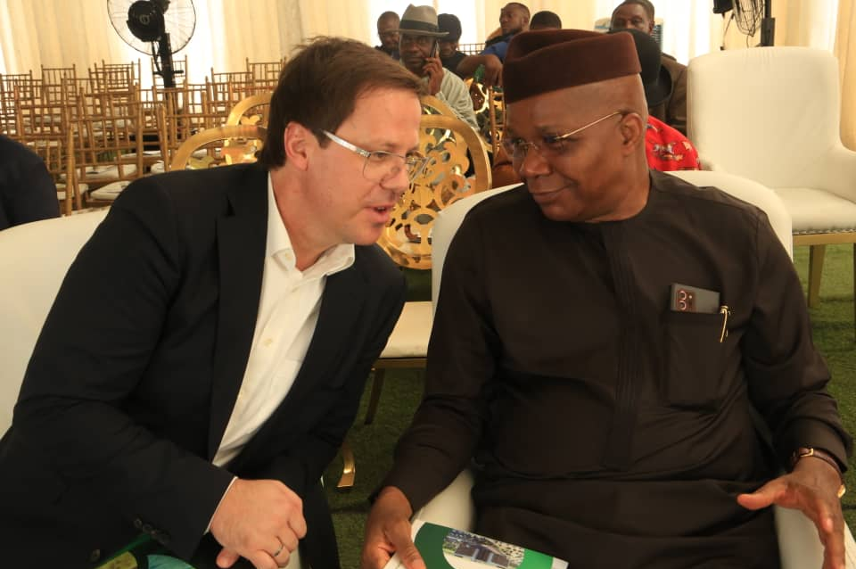
The Chairman of the Board of Directors and the Managing Director of Julius Berger Nigeria Plc, Mr. Mutiu Sunmonu, CON (right), and Engr. Dr. Lars Richter (left) during the Ground-breaking ceremony of the Olibiri Museum last tuesday

