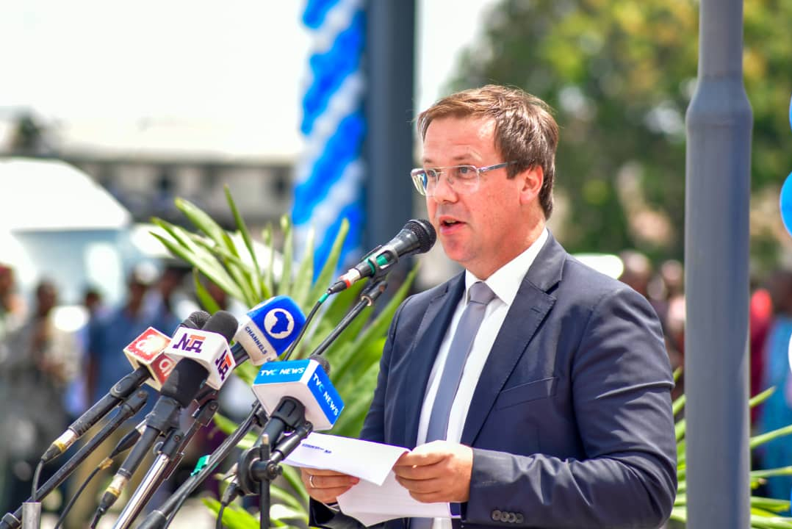
Managing Director of Julius Berger Nig. Plc, Engr. Dr. Lars Richter speaking at the commissioning of the Sir Dr. Peter Odili Cancer and Cardiovascular Disease Diagnostic and Treatment Centre in Port Harcourt, recently

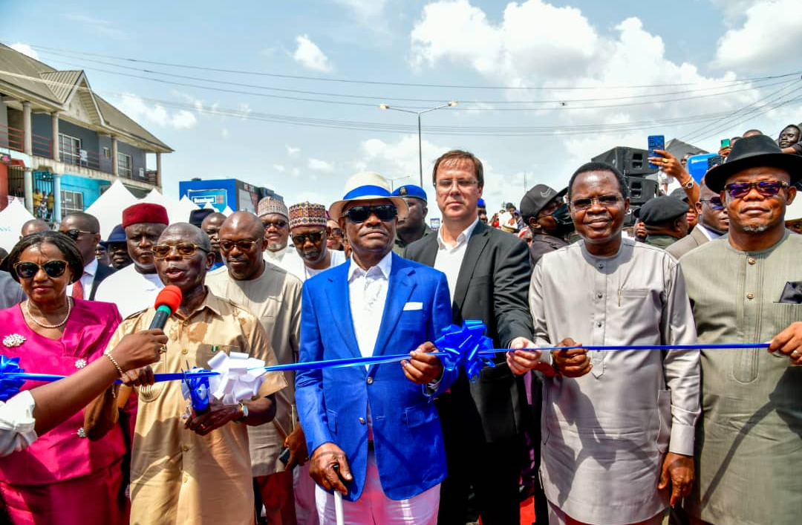
His Excellency, Gov. Nyesom Wike (Middle), the Special Guest of Honour, former Gov.of Edo State, His Excellency Comrade Adams Oshiomole(2nd left), the Dep. Gov.of Rivers State Her Excellency Dame Dr. Ipalibo Harry Banigo and the Managing Director of Julius Berger Nig. Plc, Engr. Dr. Lars Richter and other high-ranking State officials at the commissioning oft he Rumupirikom Flyover in Port Harcourt, recently

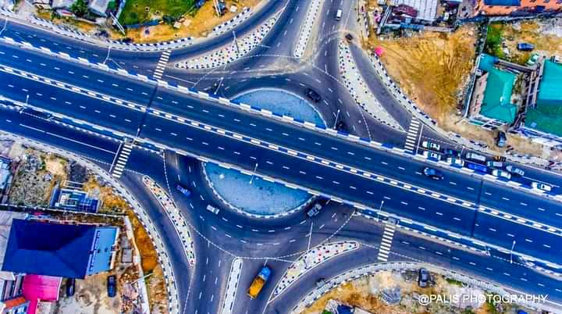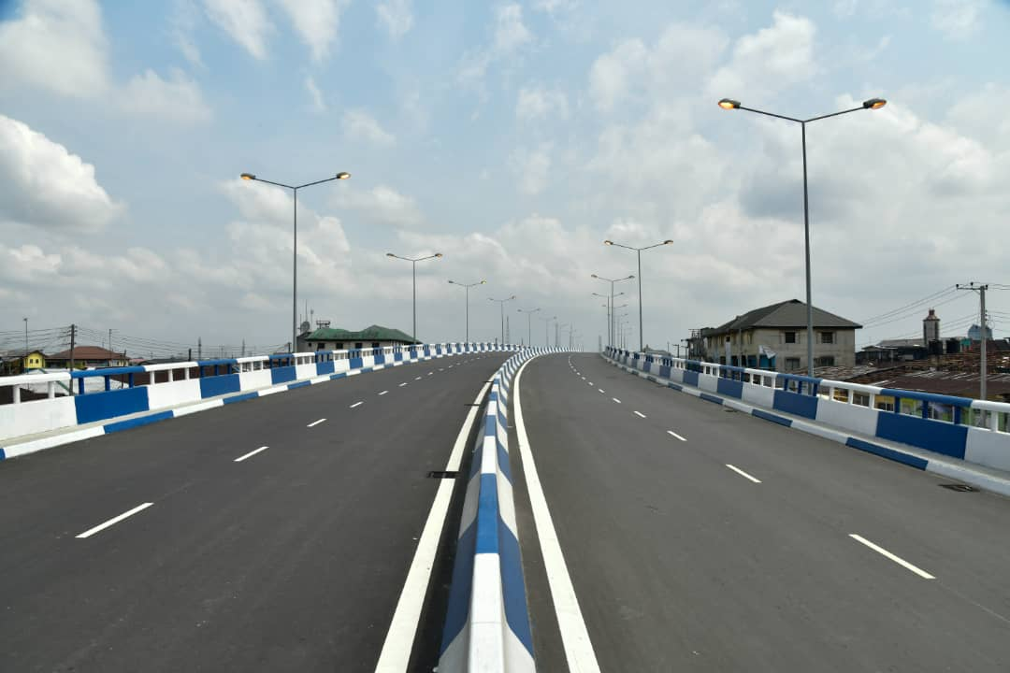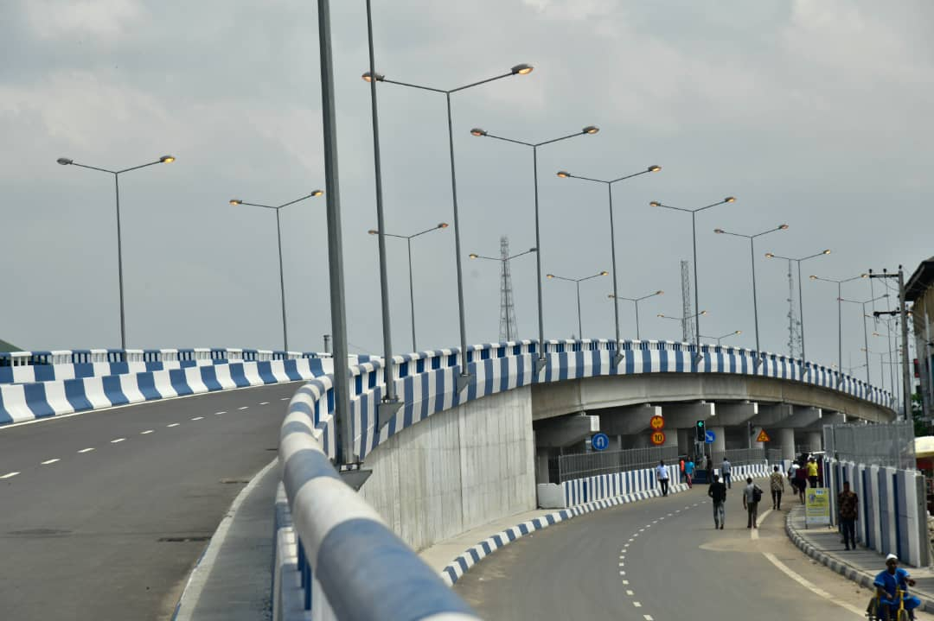
Views of the Rumupirikom Flyover built by Julius
Berger Nigeria Plc in Port Harcourt
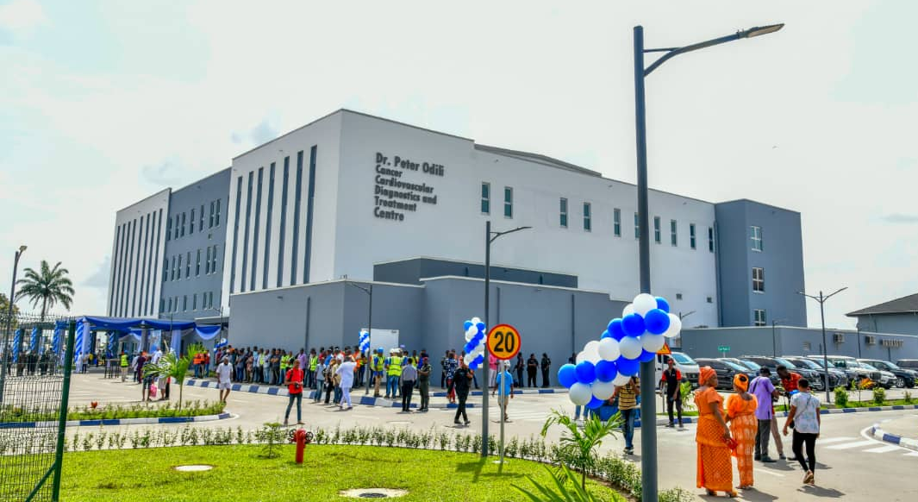
The Sir Dr. Peter Odili Cancer and Cardiovascular Disease Diagnostic
and Treatment Centre, built by Julius Berger Nigeria Plc in Port Harcourt

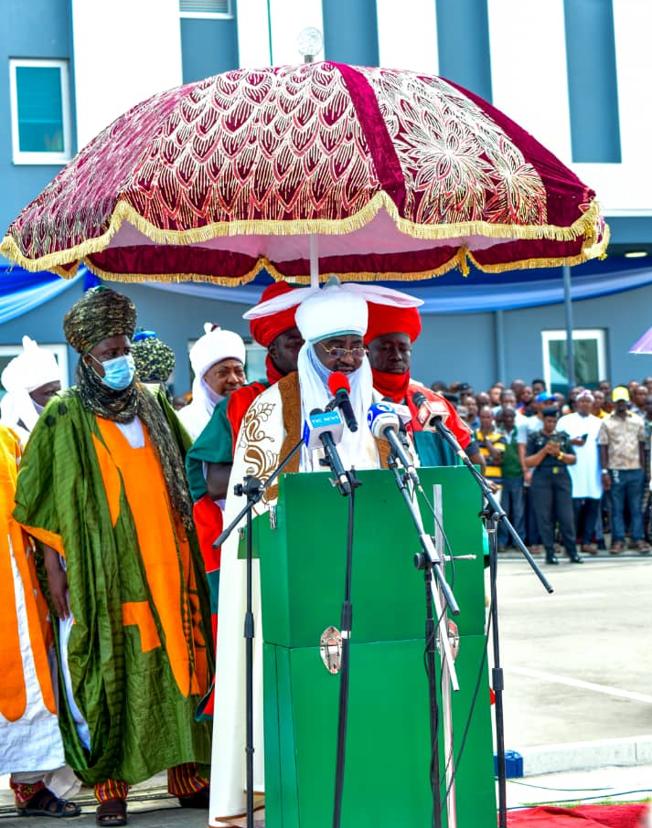
His Royal Highness, Ado Bayero, CFR, the Emir of Kado, the Special Guest of Honour speaking at the commissioning of the Sir Dr. Peter Odili Cancer and Cardiovascular Disease Diagnostic and Treatment Centre, Port Harcourt

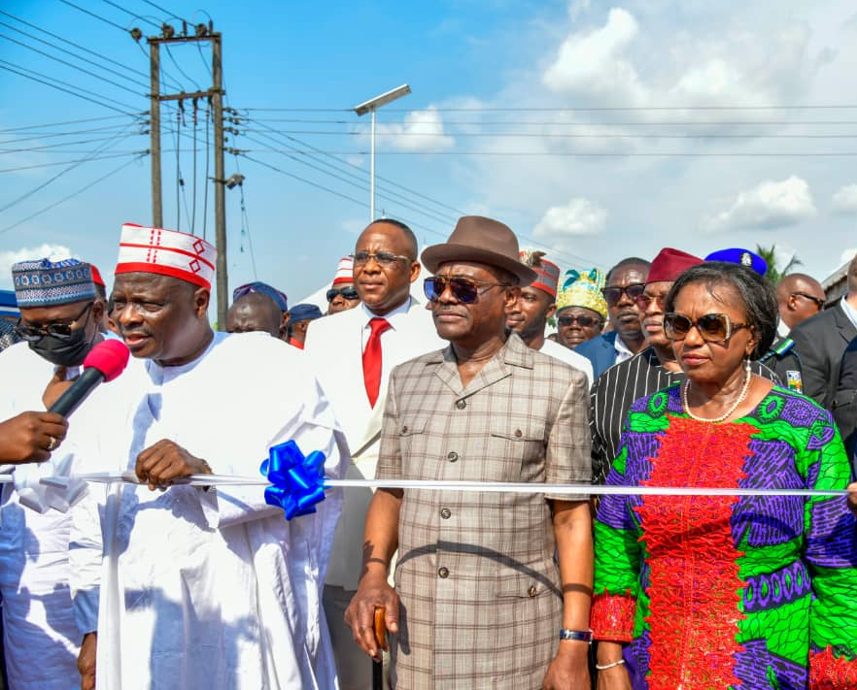
Gov. Nyesom Wike and his Dep. Dame Dr. Ipalibo Harry Banigo and Former Governor of Kano State and former Minister of Defence, His Excellency, Dr. Rabiu Musa Kwankwanso, the Special Guest of Honour at the Road commissioning ceremony in Mgbuitanwo in Emohua LGA Rivers State, recently

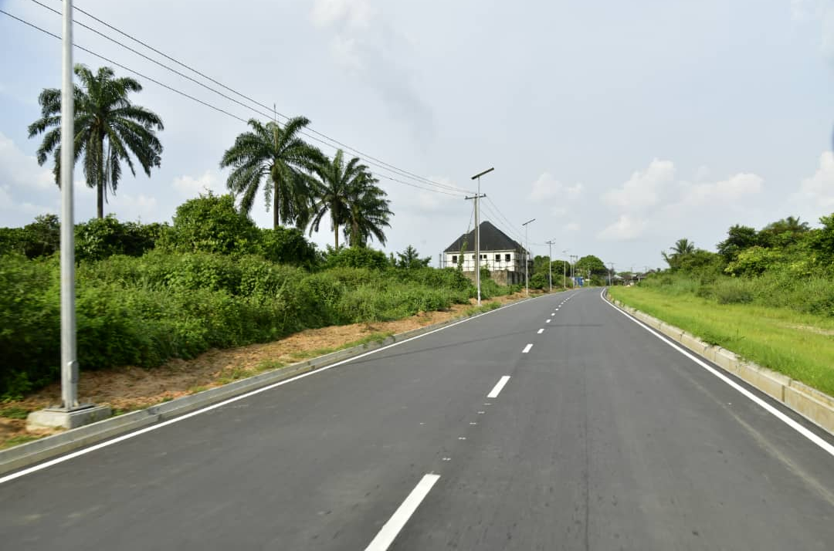
The newly commissioned Mgbuitanwo Road constructed by Julius Berger in Emohua LGA Rivers State, recently

