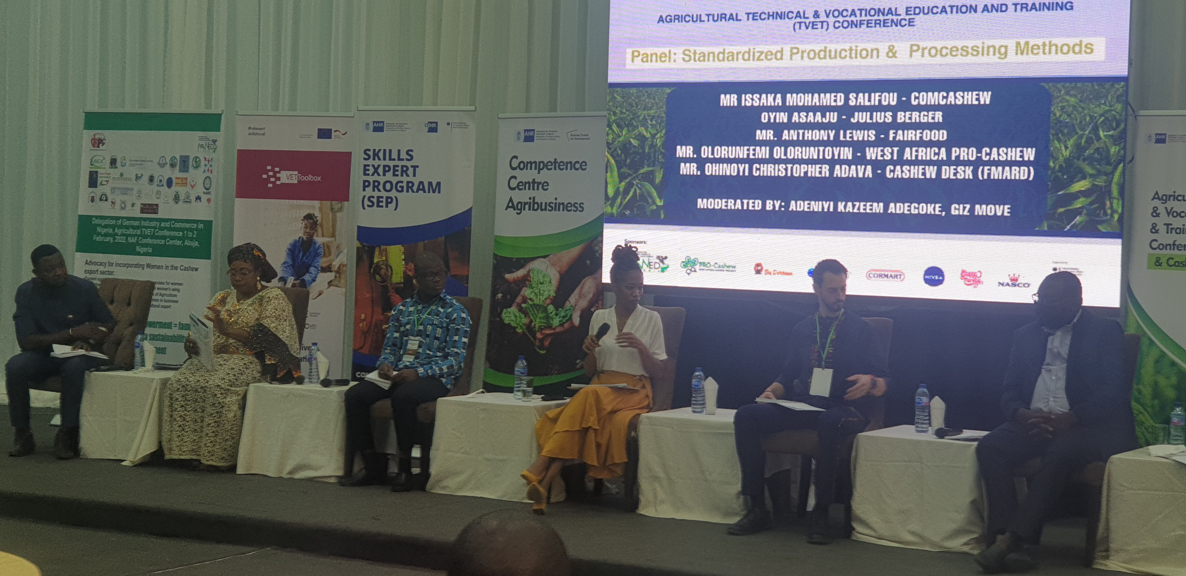
Julius Berger’s Cashew Project’s Commodity and Marketing Manager, Oyindamola Asaaju (middle and with the microphone) making a point during the panel session on Standardized Production & Processing Methods at TVET Cashew Conference in Abuja recently

